

**TRIBHUVAN UNIVERSITY**

**INSTITUTE OF ENGINEERING**

**PURWANCHAL CAMPUS, DHARAN**

**MapGAN: GENERATING MAPS FROM AERIAL IMAGES**

**BY:**

**ANUJ TIMSINA (26307)**

**PRAJWAL CHHETRI (26322)**

**SACHI KAMAT (26331)**

**SANDIP THAPA (26335)**

**A PROJECT WAS SUBMITTED TO THE DEPARTMENT OF ELECTRONICS AND COMPUTER ENGINEERING IN PARTIAL FULFILMENT OF THE REQUIREMENT FOR THE BACHELOR’S DEGREE IN COMPUTER ENGINEERING**

**DEPARTMENT OF ELECTRONICS AND COMPUTER ENGINEERING**

**DHARAN, NEPAL**

**MAY, 2022**



**TRIBHUVAN UNIVERSITY**

**INSTITUTE OF ENGINEERING**

**PURWANCHAL CAMPUS, DHARAN**

**A PROJECT REPORT ON**

**“MapGAN: GENERATING MAPS FROM AERIAL IMAGES”**

**SUBMITTED BY:**

**ANUJ TIMSINA [26307]**

**PRAJWAL CHHETRI [26322]**

**SACHI KAMAT [26331]**

**SANDIP THAPA [26335]**

**A PROJECT WAS SUBMITTED TO THE**

**DEPARTMENT OF ELECTRONICS AND COMPUTER ENGINEERING**

**IN PARTIAL FULFILMENT OF THE REQUIREMENT FOR THE**

**BACHELOR’S DEGREE IN COMPUTER ENGINEERING**

**DEPARTMENT OF ELECTRONICS AND COMPUTER ENGINEERING**

**DHARAN, NEPAL**

**MAY, 2022**

**TRIBHUVAN UNIVERSITY**

**INSTITUTE OF ENGINEERING**

**PURWANCHAL CAMPUS, DHARAN**

**DEPARTMENT OF ELECTRONICS AND COMPUTER ENGINEERING**

# CERTIFICATE

This is to certify that the project entitled, **“MapGAN: GENERATING MAPS FROM AERIAL IMAGES”** by **Anuj Timsina, Prajwal Chhetri, Sachi Kamat and Sandip Thapa** presented toward the partial fulfilment of the requirement of **Bachelor of Engineering (B.E.) degree in Computer Engineering** has been completed under my supervision. I recommend the same for acceptance by Tribhuvan University, Institute of Engineering.

....…………………..

**Er. Dharti Raj Shah**

(Project Supervisor)

**May 2022**

# © COPYRIGHT

The author has agreed that the Library, Department of Electronics and Computer Engineering, Purwanchal Campus, Institute of Engineering may make this report freely available for inspection. Moreover, the author has agreed that permission for extensive copying of this project report for scholarly purpose may be granted by the supervisors who supervised the project work recorded herein or, in their absence, by the Head of the Department wherein the project report was done. It is understood that the recognition will be given to the author of this report and to the Department of Electronics and Computer Engineering, Purwanchal Campus, Institute of Engineering in any use of the material of this project report. Copying or publication or the other use of this report for financial gain without approval of to the Department of Electronics and Computer Engineering, Purwanchal Campus, Institute of Engineering and author’s written permission is prohibited. Request for permission to copy or to make any other use of the material in this report in whole or in part should be addressed to:

Head

Department of Electronics and Computer Engineering

Purwanchal Campus, Institute of Engineering

Dharan, Nepal

# ACKNOWLEDGEMENT

First and foremost, we would like to express our gratitude to Purwanchal Campus and Tribhuvan University for providing us with the opportunity to work on this project, from which we will get valuable experience in research and other subjects. We also want to thank Er. Manoj Kumar Guragain, Head of Department and Er. Dharti Raj Shah, project supervisor for their invaluable guidance, comments, and suggestions throughout the project task and for assisting us in completing the project.

# ABSTRACT

We are aware that Google maps is an important tool for map-related services and functionalities. But the major concern is that Google maps is generally updated in 1-3 years which is a pretty long time in context of landscapes since major changes can be seen in that duration as roads and houses are constantly being constructed and hence we need maps which are up to date with those changes. Moreover, for developing countries like Nepal, map data of a lot of regions are missing. Hence, we propose a Conditional Generative Adversarial Network (cGAN) model which involves the conditional generation of images by a generator model. Our model translates the satellite images or even drone images to the corresponding standard layer map image using cGAN where the generator translates by means of a series of convolutions to the standard layer of a map and the discriminator input is the concatenation of the real/generated map and the satellite image. Since, we have access to the real map for a given satellite image, we are able to assign a quantitative metric to the quality of the generated images. Moreover, using U-net Generator and PatchGAN discriminator and calculating the reconstruction loss, generator loss and discriminator loss will also provide further improved results.

Keywords: generator, discriminator, map generation

TABLE OF CONTENTS

CERTIFICATE III

© COPYRIGHT IV

ACKNOWLEDGEMENT V

ABSTRACT VI

TABLE OF CONTENTS VII

LIST OF TABLES X

LIST OF FIGURES XI

LIST OF ABBREVIATION XII

1. INTRODUCTION 1

1.1 Background 1

1.2 Problem Statement 3

1.3 Objective 3

1.4 Project scope and applications 3

2. LITERATURE REVIEW 4

3. SYSTEM ANALYSIS 7

3.1 Requirement Analysis 7

3.1.1 Functional Requirement 7

3.1.2 Non-Functional Requirement 7

4 SYSTEM DESIGN AND ARCHITECTURE 8

4.1 System block diagram 8

4.2 Use case diagram 9

4.3 System Flow Diagram 10

4.4 Activity Diagram 11

4.5 Sequence Diagram 12

5 METHODOLOGY 13

5.1 Processes 13

5.1.1 Fact Findings and Data Collection 14

5.1.2 Project Analysis 15

5.1.3 System Design 15

5.1.4 Building the System 15

5.2 Generative Adversarial Network (GAN) 16

5.2.1 Convolution Neural Networks 16

5.2.2 Conditional GAN 18

5.2.3 U-net Generator 19

5.2.4 PatchGAN Discriminator 19

5.2.5 Algorithm for GAN 20

5.2.6 Network Architecture 21

5.2.7 Hyper-parameters 25

6 RESULT AND ANALYSIS 26

6.1 Result 26

6.2 Generator and Discriminator Loss 26

6.3 Testing 27

6.3.1 Testing for output result of satellite images 27

6.3.2 Testing for output result of images other than satellite images 28

7 CONCLUSION 29

8 RECOMMENDATIONS 30

9 REFERENCES 31

10 APPENDICES 33

10.1 Some snapshots of the project 33

# LIST OF TABLES

Table 6.1 Testing for the output for satellite or drone images 24

Table 6.2 Testing for the output of garbage images 24

# LIST OF FIGURES

Figure 4.1 System Block Diagram of Standard Maps Generation from Satellite Images using Conditional GAN 10

Figure 4.2 Use Case Diagram of Standard Maps Generation from Satellite Images using Conditional GAN 11

Figure 4.3 System Flow diagram of Standard Maps Generation from Satellite Images using Conditional GAN 12

Figure 4.4 Activity Diagram of Standard Maps Generation from Satellite Images using Conditional GAN 13

Figure 4.5 Sequence Diagram of Standard Maps Generation from Satellite Images using Conditional GAN 14

Figure 5.1 GAN Architecture 16

Figure 5.2 Conditional Generative Adversarial Network Model Architecture 18

Figure 5.3 Encoder-decoder vs. U-Net Generator 19

Figure 5.4 Dimension of output image 21

Figure 5.5 5x5 image matrix and 3x3 filter matrix 21

Figure 5.6 Feature Map after convolution 22

Figure 5.7 Sigmoid function 23

Figure 5.8 Hyperbolic tangent function 23

Figure 6.1 Generator and Discriminator Loss 26

Figure 7.1 Maps containing roads, highway and open land generated.........................27

Figure 10.1 System User Interface 33

Figure 10.2 Maps including roads 34

Figure 10.3 Maps containing roads and buildings 34

Figure 10.4 Maps containing roads and open lands 35

Figure 10.5 Maps containing roads, buildings and open lands 35

Figure 10.6 Maps containing roads, buildings and lake 36

Figure 10.7 Maps containing roads and buildings 36

Figure 10.8 Maps including roads, buildings and open lands 37

Figure 10.9 Maps including roads and buildings 37

Figure 10.10 Maps including roads and highways 38

# LIST OF ABBREVIATION

API: Application Programming Interface

cGAN: Conditional Generative Adversarial Network

CNN: Convolutional Neural Network

COCO: Common Objects in Context

DH-GAN: Dual-Hop Generative Adversarial Network

GAN: Generative Adversarial Network

MNIST: Modified National Institute of Standards and Technology

ResNet: Residual Neural Network

SPA: Spatial Attention

UAV: Unmanned Aerial Vehicle

UML: Unified Modelling Language

# 1. INTRODUCTION

## Background

Digitized data about the surrounding space is used to create automated cartographic and geographic information systems. Compared to traditional maps, electronic models have a better advantage since they have higher accuracy and absence of distortions as well as automatic routing and control over deviations from the selected course. It also has the possibility of digital marking and instantaneous search for the necessary object. Creating accurate maps has always been a tedious task and it has become a major challenge for companies that want to sell smart devices such as mobile phones, watches, etc. since a major factor which makes a device smart is the ability to accurately locate itself and inform its user via an appropriate interface.

More importantly, maps have a huge humanitarian value. We can use spatial data and cartographic products to improve situational awareness and decision-making around humanitarian issues from acute events such as natural disasters and public health emergencies to longer term events such as refugee crises and political unrest. Big data based on location and behavioral attributes produced online and through interaction with digital systems and networks can also be exploited to enhance information environments. Electronic maps are the most convenient approach to this.

However, there are still some challenges which we face when creating electronic maps and one large disadvantage is the difficulty in producing one complete digital world map or full-scale maps because of the costs involved and the mass of information that would need to be stored and accessed. Additionally, there is also the issue of requiring to vectorize paper maps first and then involves complex graphic editing manually by industry standards which consumes a lot of manpower and resources.

The actual geographic conditions or street views and the publicly available human-readable maps have a significant amount of latency associated with them. Automating this process of converting a satellite image into a human-readable map is one way to reduce this latency. The automation can be achieved by using Generative models. In this work, we emphasize the importance of human-readability of a map and aim to construct accurate human-readable maps directly from a satellite/aerial image of the location. The satellite/aerial image specifies the zoom level and resolution of the required map.

If a generative model can be trained to directly convert remote sensing images into corresponding electronic maps, the production of electronic maps will be accurate and rapid, thereby further improving the service level for society.

## Problem Statement

The satellite images provided by sources such as Google is normally updated once every three years. This causes problems of using outdated satellite images when required.

## Objective

"Generate a standard layer of maps from satellite images using conditional-GAN."

## Project scope and applications

The project scope and applications of the project are listed below:

* Standard layers of maps can be generated by giving direct satellite or drone images.
* Maps can be generated more accurately and in real time with the help of drone images also since the satellite images provided by sources such as Google is normally updated once every three years.
* Can be used to generate maps from the places where the maps aren’t available easily.
* Maps can be generated of the places which is not shown by existing standard maps.

# 2. LITERATURE REVIEW

Image-to-image translation aims to transfer images from a source domain to a target domain while preserving the content representations. Image-to-image translation has drawn increasing attention and made tremendous progress in recent years because of its wide range of applications in many computer vision and image processing problems such as image synthesis, segmentation, style transfer, restoration and pose estimation [1].

In 2014, Ian Goodfellow and his colleagues from University of Montreal introduced Generative Adversarial Networks (GANs). It was a method of learning an underlying distribution of the data that allowed generating artificial objects that looked strikingly similar to those from real life. Goodfellow wondered if two neural networks could work in tandem. One network could learn about a data set and generate examples; the second could try to tell whether they were real or fake, allowing the first to tweak its parameters in an effort to improve [2].

Over a few years, application of the Generative Adversarial Networks (GANs) have seen astounding growth. The technique has been successfully used for high-fidelity natural synthesis, data augmentation tasks, improving image compressions, and more. From emoting super-realistic expressions to exploring deep space and from bridging the human-machine empathetic disconnect to introducing new art forms, GANs have it all covered. It has enabled the generation of high-resolution photorealistic images and videos, a task that was challenging or impossible with prior methods. It has also led to the creation of many new applications in content creation.

Conditional adversarial networks are being investigated by Philip Isola and his team as a general-purpose solution to image-to-image translation difficulties. Not only do these networks learn the mapping from input to output image, but they also learn a loss function to train this mapping [5]. This allows the same generic method to be applied to problems that previously required highly diverse loss formulas. Before learning about GANs, Isola was exploring with nearest-neighbor methods to try to understand the fundamental structure of objects and scenes. He then utilized GAN, which combines two neural networks: a generator that generates an image pattern after training examples and a discriminator that determines how well the generator's output matches the training data. If the discriminator can tell its fake, the generator tries again until its output images are indistinguishable from the examples.

Image-to-image translation, according to Yingxue Pang and colleagues, tries to move images from a source domain to a destination domain while retaining the content representations.

Hajar Emami and colleagues suggested a unique spatial attention GAN model (SPA-GAN) for image-to-image translation that included the attention mechanism directly into the GAN architecture [6]. GANs have also been used to construct spoof satellite photos and spoof ground truth images based on the location's satellite image [7]. Ground-level representations of sites have also been generated using conditional GANs from above satellite photos [8].

In their paper, Mehdi Mirza and colleagues introduced the conditional version of generative adversarial networks, which was built by simply feeding the data they wanted to condition on to both the generator and discriminator in order to demonstrate that their model could generate MNIST digits conditioned on class label. They described one approach to unsupervised learning via generative modeling called generative adversarial networks in their overview paper. They discussed GAN applications briefly and underlined major research concerns relating to game convergence that must be addressed in order for GANs to be a trustworthy technology.

In their research, Wallace Lira and colleagues introduced GANHopper, an unsupervised image-to-image translation network that gradually converts pictures across two domains over numerous hops [9].

Dragos Costea and his team noticed that automatic road and intersection recognition from aerial photos is a difficult challenge in computer vision with various applications in UAV localization and navigation. So they introduced the DualHop GAN (DH-GAN), which can detect roads and intersections and then utilize a smoothing-based graph optimization approach to obtain the optimal covered road graph [10].

Timo Carras and his colleagues developed a style transfer-inspired alternate generator architecture for generative adversarial networks. When trained on human faces, the new architecture results in an unsupervised, automatically learnt separation of high-level features such as head posture and freckles. With this paper, a fresh, extremely variable, and high-quality dataset of human faces was introduced.

Stack GAN was developed by Han Zhang, Tao Xu, and their colleagues to produce 256256 photo-realistic images based on text descriptions. Through a sketch-refinement process, the difficult problem is broken into more manageable sub-problems. The goal of Stack GAN is to create high-resolution photorealistic images. For text-to-image synthesis, Stack GAN-v1 is a two-stage generative adversarial network architecture is suggested [11]. The Stage-I GAN creates low-resolution images by sketching the object's rudimentary shape and colors based on a text description. Stage-II GAN generates high-resolution images with photo-realistic details using Stage-I findings and text descriptions as inputs [11]. Second, a multi-stage generative adversarial network design with sophisticated features. For both conditional and unconditional generation tasks, Stack GAN-v2 is offered. Extensive tests show that the proposed stacked generative adversarial networks greatly improve performance.

In their research, Arantxa Casanova and colleagues proposed Instance Conditioned GAN, which claims that GANs may produce images that are nearly photo realistic in confined domains such as human faces [12]. In unconditional circumstances, however, modeling complex distributions of datasets like ImageNet and COCO-Stuff remains difficult. They used kernel density estimation techniques as inspiration and developed a non-parametric way to modeling complex dataset distributions. They divided the data manifold into overlapping neighborhoods defined by a datapoint and its immediate neighbors, then used an instance-conditioned GAN model to learn the distribution around each datapoint. IC-GAN greatly enhanced unconditional models and unsupervised data partitioning baselines on ImageNet and COCOStuff, according to experimental results.

The conditional GAN architecture is used in this research to generate a map for a location given a satellite image of the location. We also write technology that makes it possible to create new datasets using the Google Earth Engine and Google Maps APIs, which are both freely available.

The appeal of GANs stems from its effective ability to model high-dimensional data, handle missing data, and produce multi-modal outputs or numerous probable solutions.

The success of GANs is perhaps the most compelling reason for their widespread study, development, and use. GANs have created photographs that are so lifelike that humans are unable to distinguish between real objects, sceneries, and individuals.

Some of the main benefits of GAN over other algorithms are:

* Convergence will be faster. Even the random distribution that fake images follow will have some patterns.
* We can control output of the generator at test time by giving the label for the image we want to generate.

# SYSTEM ANALYSIS

## Requirement Analysis

### Functional Requirement

These are the requirements that the end user specifically demands as basic facilities that the system should offer.

* Users can acquire maps of any place having satellite images.
* The system can generate desired maps for every satellite image.

### Non-Functional Requirement

A software system's quality characteristic is defined by a non-functional need. These are the quality restrictions that the system must meet in order to achieve higher performance and quality. Non-behavioral requirements are another name for them.

* The system is simple to use and understand.
* The system is efficient, delivering the result as quickly as possible;
* The system is quite dependable in terms of the results it displays, i.e. there is no bogus data.
* Because it can be used on big datasets, the system is scalable.
* Our system is versatile in that it may be applied to a variety of scenarios. It isn't restricted to satellite photos as an input.

# SYSTEM DESIGN AND ARCHITECTURE

## System block diagram

The block diagram of our system is shown below. The datasets are obtained first, and then they are trained. The user enters a satellite image into the system after the datasets have been trained, which is then delivered to the generator. The generator is now in charge of creating fictitious visuals or maps. The discriminator determines if the maps generated by the generator are acceptable; if not, reconstruction loss is calculated, and the generator must create a new map until the discriminator can no longer distinguish between actual and fake images.

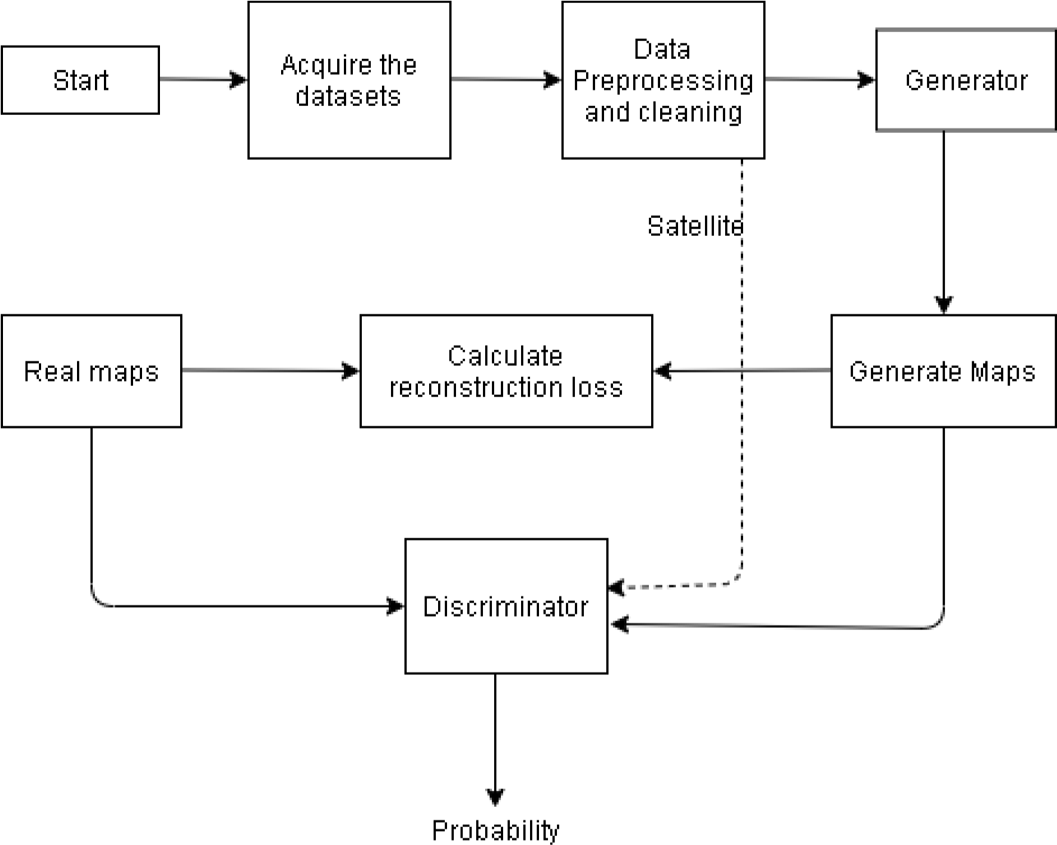

Figure 4.1 System block diagram of standard maps generation from satellite images using conditional GAN

## Use case diagram

The diagram below shows the use case diagram of the project. The main actors shown are the user and the system. The user can only be able to post satellite images, search for the maps and then view the maps for the given satellite image. The system can train different datasets into the system, for the generator and the discriminator, update the data as per required and then display the output.

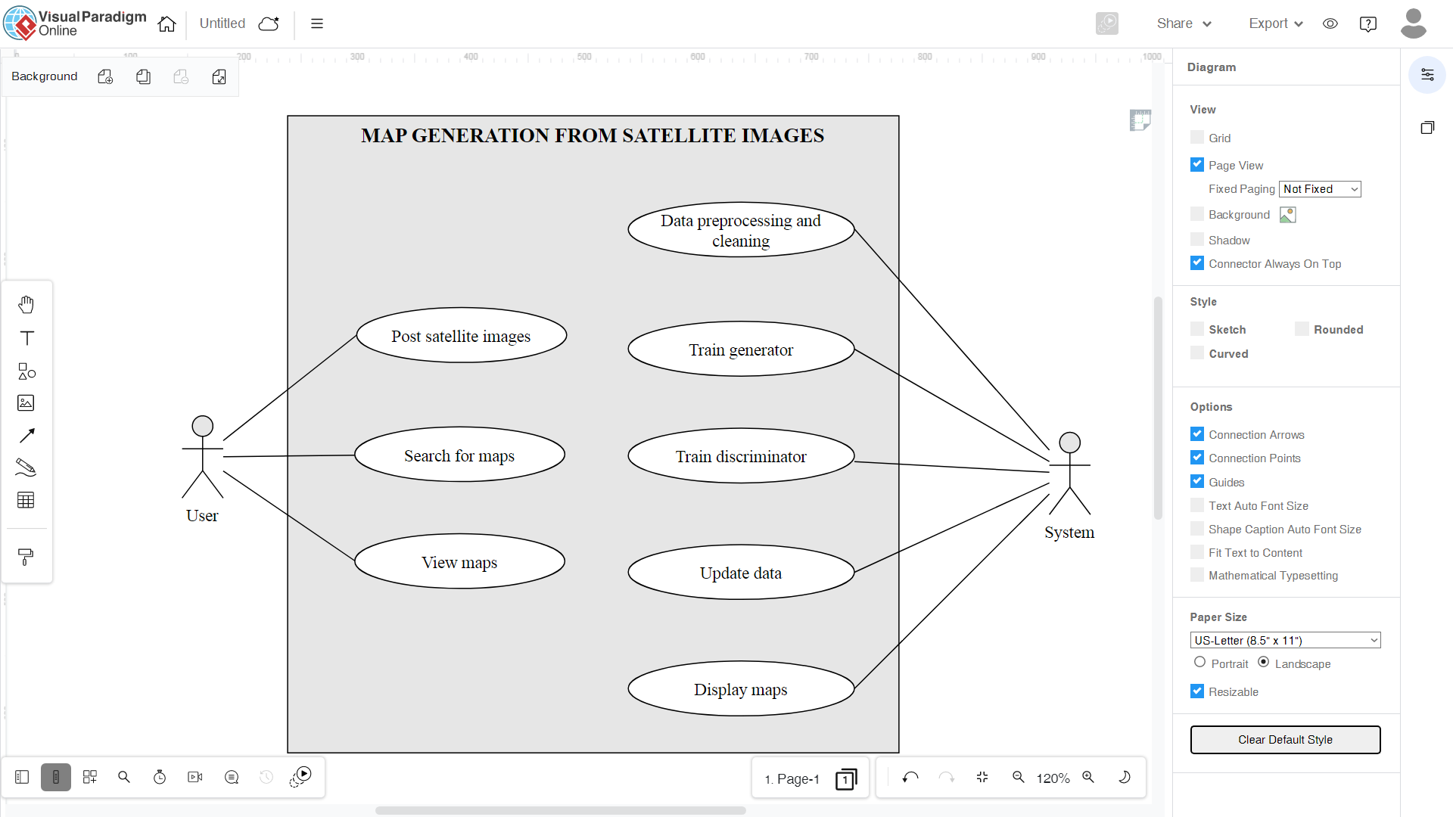

System

User

Figure 4.2 Use case diagram of standard maps generation from satellite images using conditional GAN

## System Flow Diagram

The flow of our system is depicted in the diagram below. Users insert satellite photos, after which the generator generates maps of the image and transmits them to the discriminator. If the discriminator detects that the generated images are fraudulent, the generator must generate a new image; otherwise, the generated map is presented.

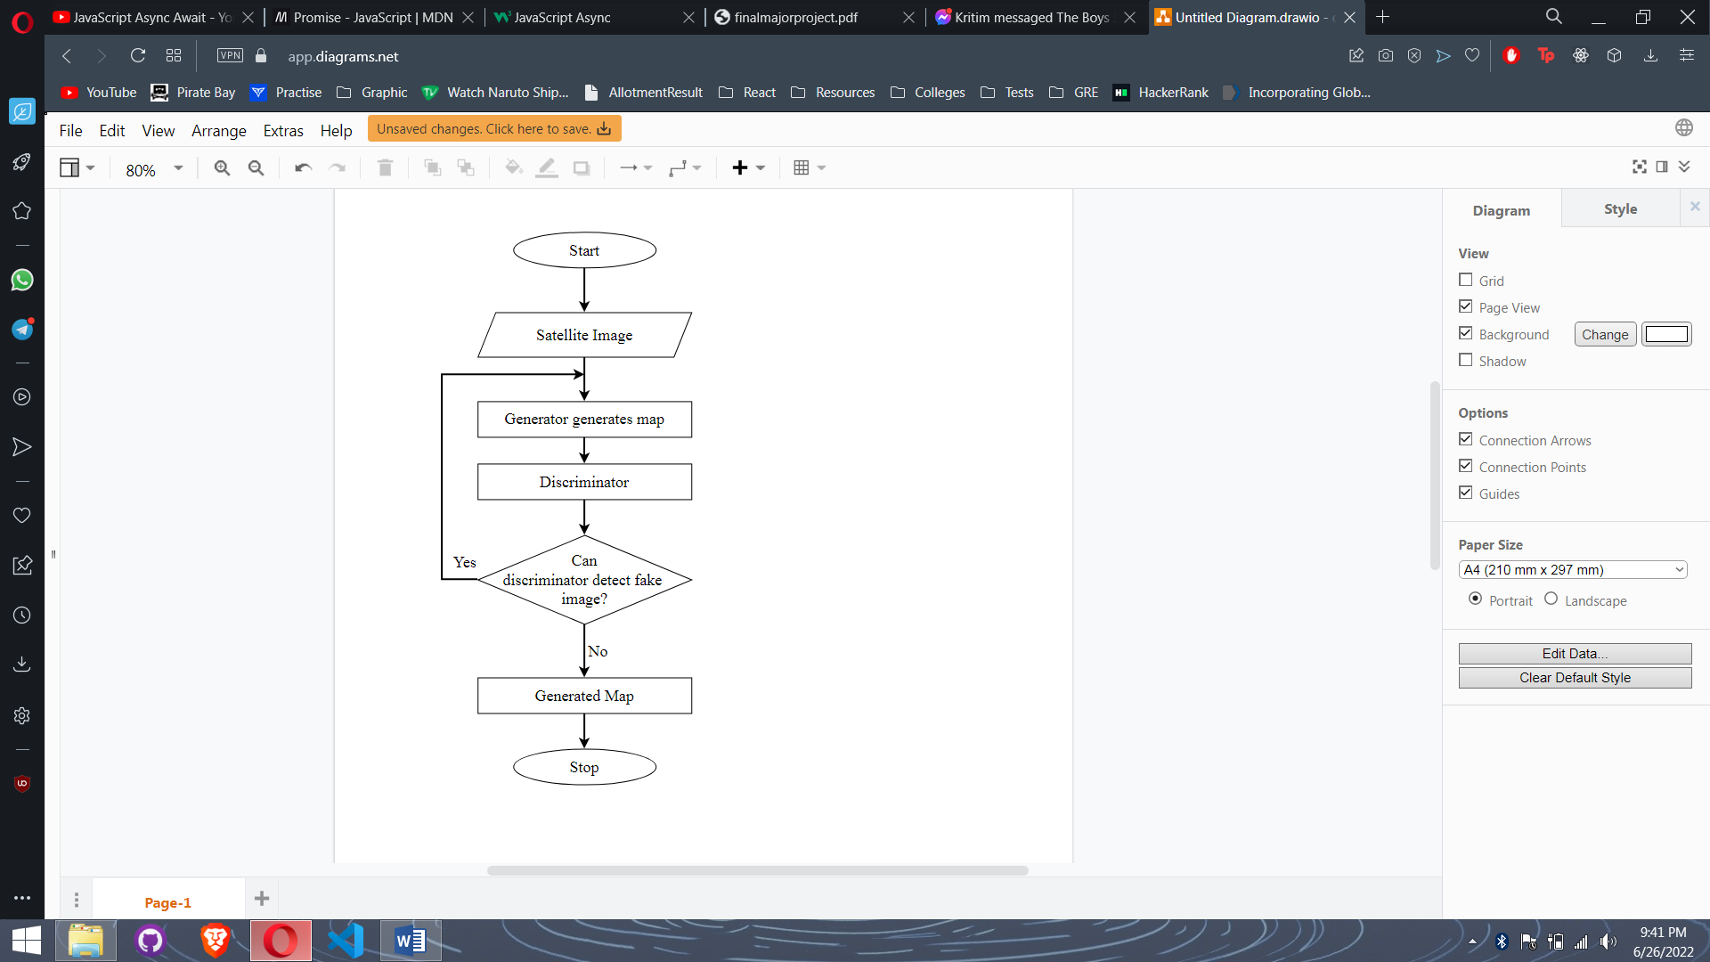

Figure 4.3 System flow diagram of standard maps generation from satellite images using conditional GAN

## Activity Diagram

Our system's activity is depicted in the diagram below. User, generator, and discriminator are the three lanes. The user lane displays what the user can do and see in the system, the generator generates maps until the discriminator can no longer tell the difference between real and fake images, and the discriminator displays the generated maps if it can't figure out which is which.

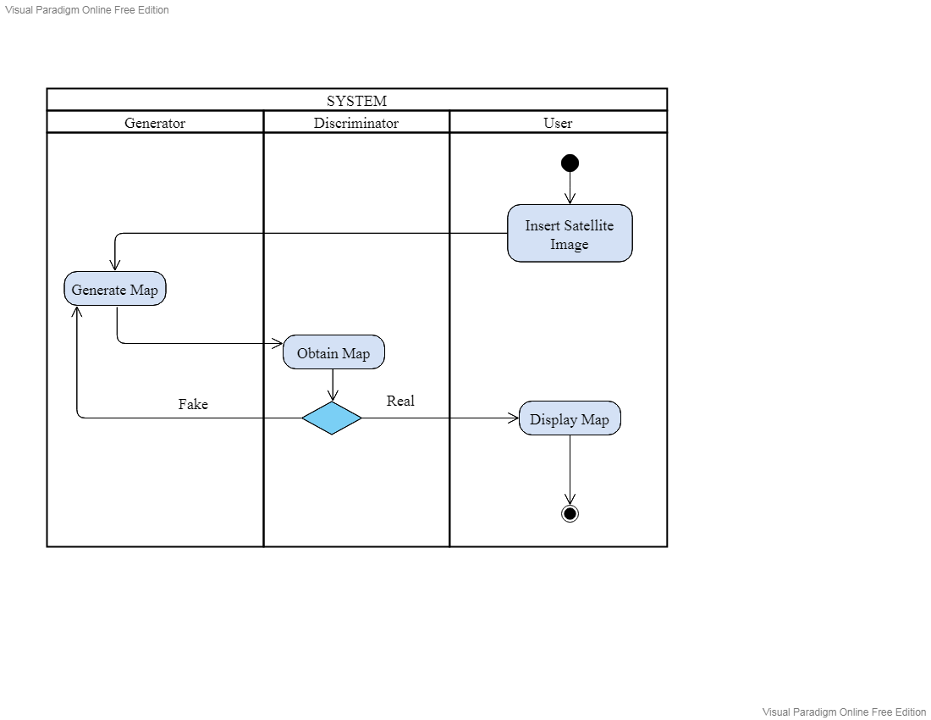

Figure 4.4 Activity diagram of standard maps generation from satellite images using conditional GAN

## Sequence Diagram

The system's sequence diagram is shown in the graphic below. The actor in the system begins by inserting a satellite image. As illustrated, the generator object becomes active, and a map is created. The discriminator receives the map after that. When the discriminator detects whether the created image is true or fraudulent, a message is delivered to the generator to renew the maps; otherwise, the map is displayed to the actor.

Actor

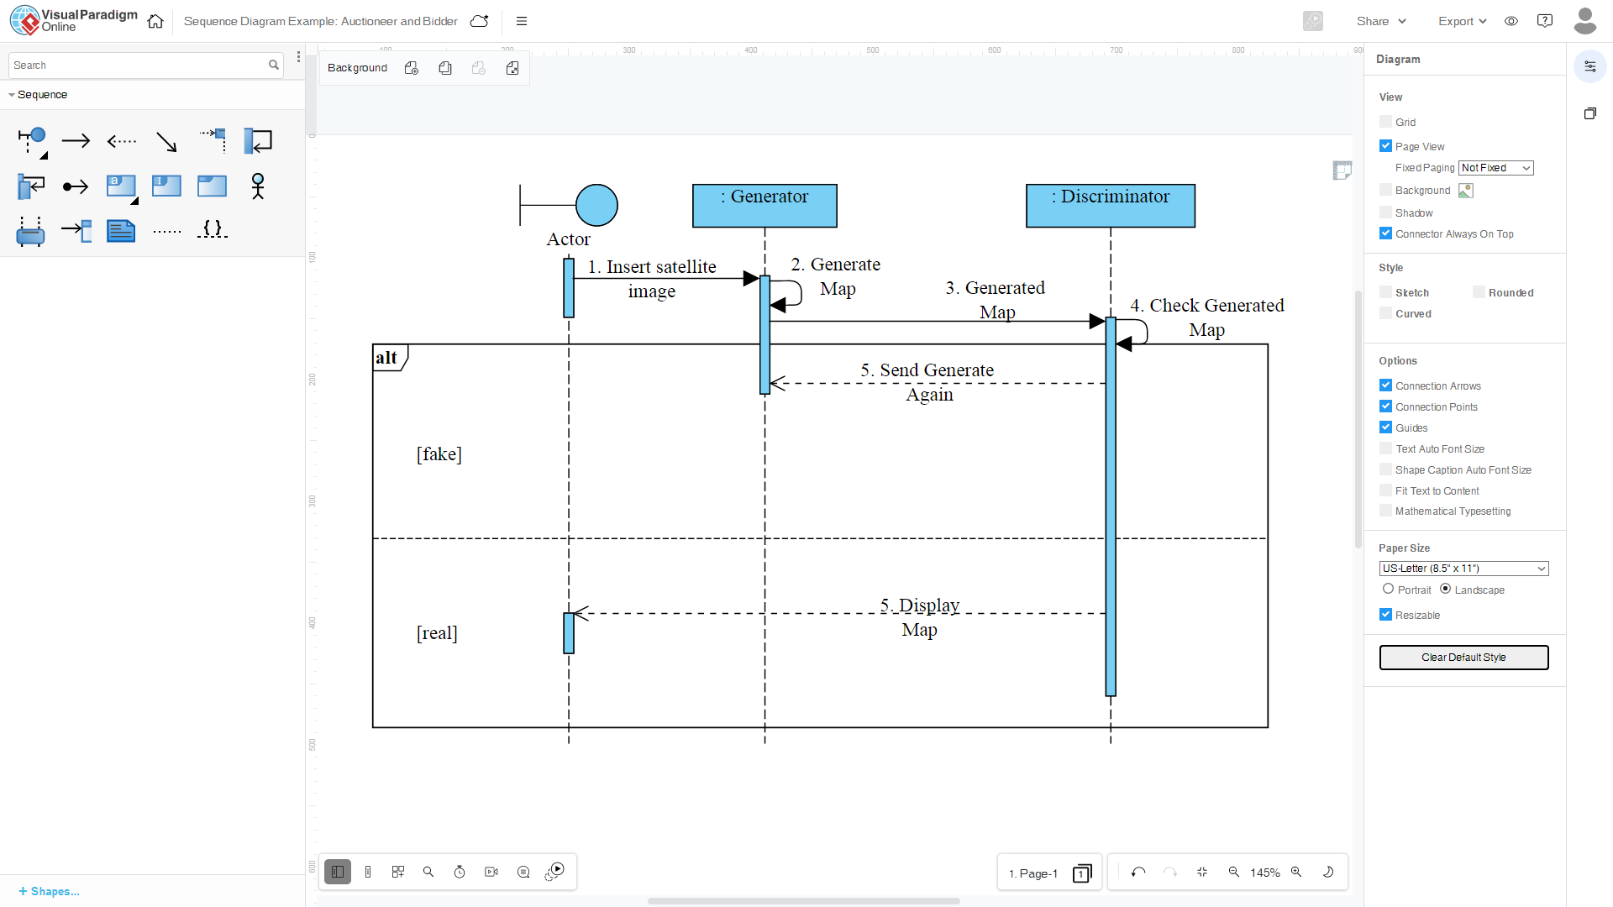

5. Send Generate   
Again

4. Check Generated   
Map

2. Generate Map

5. Display  
Map

[real]

[fake]

1. Insert

satellite image

:Generator

:Discriminator

3. Generated  
Map

Figure 4.5 Sequence diagram of standard maps generation from satellite images using conditional GAN

# METHODOLOGY

## 5.1 Processes

**5.1.1 Fact Findings and Data Collection**

The initial stage in this endeavor was to gather information on how this system operates in practice. We needed information on the generator's and discriminator's roles and functions, as well as the services users receive in current models or systems. We used the internet, research articles, and other sources to do this. We then gathered the information we needed for our individual project.

**5.1.2 Project Analysis**

Following the collecting of data and facts, we completed the job. We analyzed the requirements, such as the functionality of the project we supplied to the user, the project's security, the project's efficiency, and so on. We also conducted a feasibility analysis to see whether the project is technically, operationally, and commercially feasible.

### 5.1.3 System Design

We built use case diagrams, activity diagrams, system block diagrams, system flow diagrams, and many other types of system designs here. It allows us to visualize our system graphically.

**5.1.4 Building the System**

Following the establishment of the system design, we began to construct the system. For our system, we created the generator and discriminator models.

## Generative Adversarial Network (GAN)

There are two networks in the GAN methodology: a Generator and a Discriminator. They compete against one other in a game. The Generator's goal is to create an object that seems like a real human, such as a photograph of a person (Brownlee, 2022)**.** The Discriminator's purpose is to be able to distinguish between produced and actual images (Brownlee, 2022).

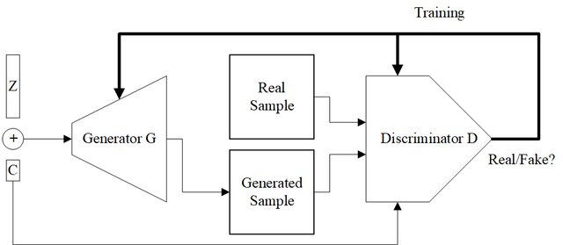

Figure 5.1 GAN architecture

### 5.2.1 Convolution Neural Networks

Convolutional Neural Networks, or CNNs, are commonly used as the generator and discriminator models in GANs.

There are two types of GAN models: generative and discriminative. The generative model has been trained on some data, say 'x', sampled from some genuine distribution, say D, and is the one that produces a distribution D', which is near to D, given more random values, Z (G. Ladhar, 2021). We've used a probability distribution function to train the datasets. The generator produces random images based on the same probability distribution function as the original dataset. The discriminative model is the one which discriminates between two different classes of data. The main objective of this is to classify whether the generated image is fake or not fake.

Consider a set of datasets based on the D distribution, which is D(x), where x is a single dataset element. Let Pz(z) be the random variable distribution, where z is a single member of P.

The value of the loss function is used by the generative adversarial network, which is given by:

L(y’,y) = [y log y’ + (1 – y) log (1 – y’)]…………………………………………..(5. 1)

Here, y’ is the reconstructed image from the generator and y is the original image from the trained dataset.

The label that is coming from Pdata(x) is y=1 and y’=D(x), so putting the values, we get;

L(D(x),1)= log (D(x))……………………………………………………………..(5. 2)

Also, for the data coming from the generator, the label y=0 and y’=D(G(z)), so in this case, we get;

L(D(G(z),0) = log(1-D(G(z)))…………………………………………………….(5. 3)

We know that the discriminator's goal is to distinguish between bogus and authentic datasets. The above two equations should be optimized for this. The condition of maximization for discriminator is D(G(z))=0, hence we get for discriminator:

Discriminator = max [log(D(x))+log(1-D(G(z)))] ……………………………...(5. 4)

For the generator, the above equations should be minimized, and its condition is

D(G(z))=1, so for generator, we get;

Generator = min [log(D(x))+log(1-D(G(z)))] …………………………………...(5. 5)

Writing it in same equations, we get;

min(G) max(D) [log(D(x))+log(1-D(G(z)))]……………………………………….(5. 6)

The function we obtained from above is for a single instance of dataset x. if we have to consider all the instances, then

min(G) max(D) V(D,G)= Ex~P(x) [log(D(x))]+ Ez~Pz(z) log(1-D(G(z)))]……………...(5.7)

**5.2.2 Conditional GAN**

The generative model is trained to produce new examples from the input domain, where the input, a random vector from the latent space, is (conditionally) provided (M. Mirza, 2014). A class value, such as male or female in the case of creating photographs of humans, or a digit in the case of generating images of handwritten numerals, might be used as an additional input.

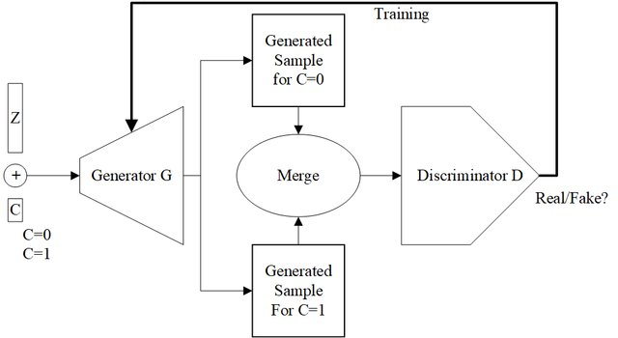

Figure 5.2 Conditional generative adversarial network model architecture

The issue with simple GAN is that we have no control over the output. As a result, conditional GAN is employed to tackle the problem. Labels are simply added to the GANs as a condition.

From above expression, using label as y, we get, the expression of conditional GAN as;

**min(G) max(D) V(D,G)= Ex~P(x) [log(D(x|y))]+ Ez~Pz(z) log(1-D(G(z|y)))]**…………(5. 8)

**5.2.3 U-net Generator**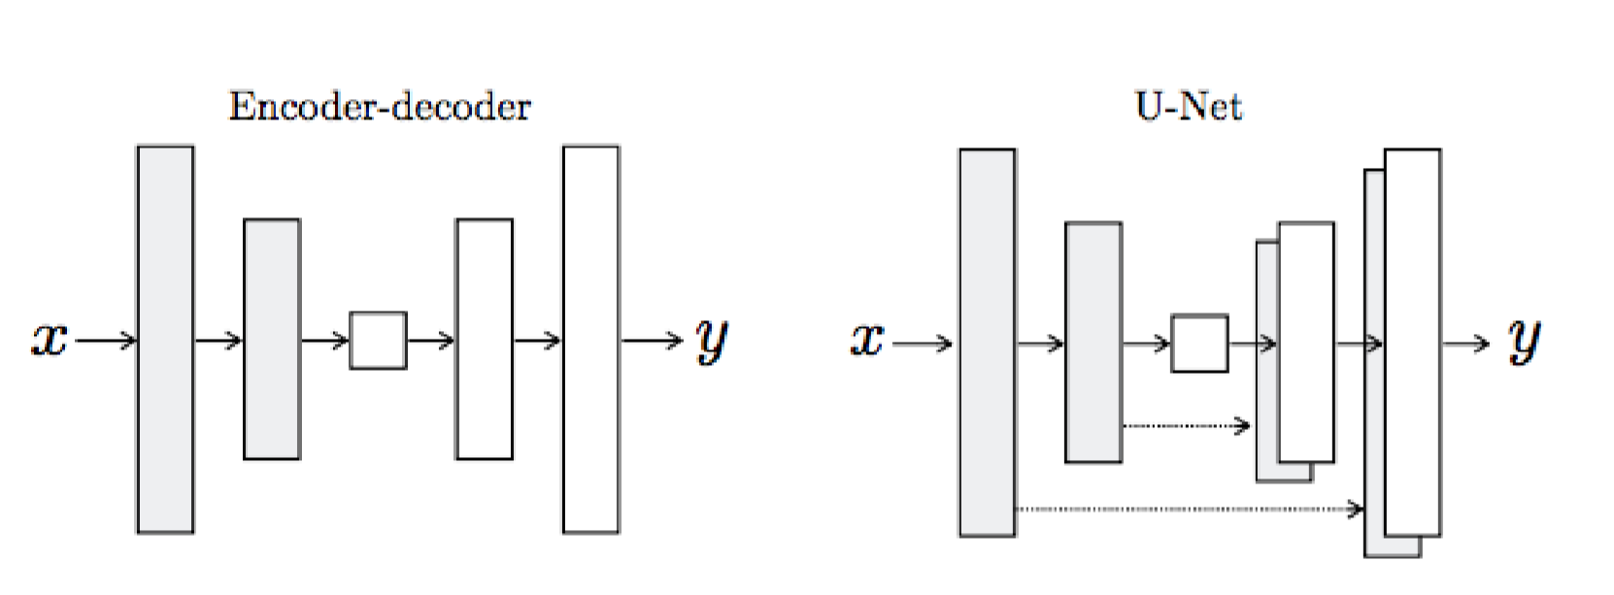

Figure 5.3 Encoder-decoder vs. U-Net Generator

The Generator takes the image to be translated and compresses it into a low-dimensional, vector-based representation (I. Goodfellow, 2021). The Generator then figures out how to incorporate this into the final image. It's worth thinking about the distinctions between the traditional Encoder-Decoder structure and the U-Net, as seen in the graphic above. In the same manner that information from older layers is absorbed into later layers, the U-Net is analogous to ResNets. The U-Net skip connections are especially appealing because they do not necessitate any scaling, projections, or other adjustments because the spatial resolution of the layers being connected is already compatible.

**5.2.4 PatchGAN Discriminator**

Instead of classifying the full image as "genuine vs. fake," the PatchGAN discriminator classifies individual (N x N) patches in the image as "real vs. fake" (Z. Wang, 2019). More limitations are imposed as a result, encouraging crisp high-frequency detail. PatchGAN also has less parameters and is faster than classification of the complete image.

**5.2.4 Algorithm for GAN**

**for** number of training iterations **do**

**for** *k* steps **do**

* Sample minibatch of *m* noise samples {z(1), … , z(m)} from noise prior pg(z).
* Sample minibatch of *m* examples {x(1), … , x(m)} from data generating distribution pdata(x)
* Update the discriminator by ascending its stochastic gradient :

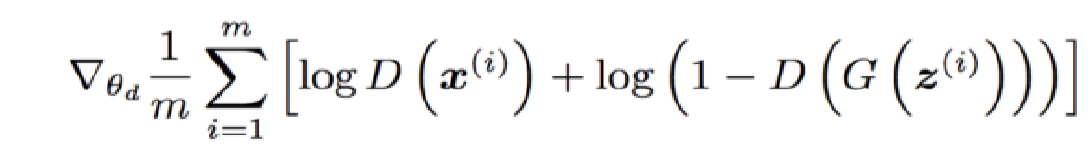 [2]……………….*(5. 9)*

**end for**

* Sample minibatch of m noise samples {z(1), … , z(m)} from noise prior pg(z). ● Update the generator by descending its stochastic gradient :

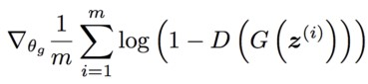 [2]*…………………………………….. …...(5. 10)*

**end for**

**5.2.6 Network Architecture**

Both generator and discriminator use modules of the form Convolution-BatchNorm- ReLu. Convolution is the first layer to extract features from an input image. Convolution preserves the relationship between pixels by learning image features using small squares of input data. It is a mathematical operation that takes two inputs such as image matrix and a filter such that:

* An image matrix (volume) of dimension **( h × w × d )**
* A filter **( fh × fw × d )**
* Outputs a volume dimension **( h- fh + 1) × ( w – fw + 1 ) × 1**

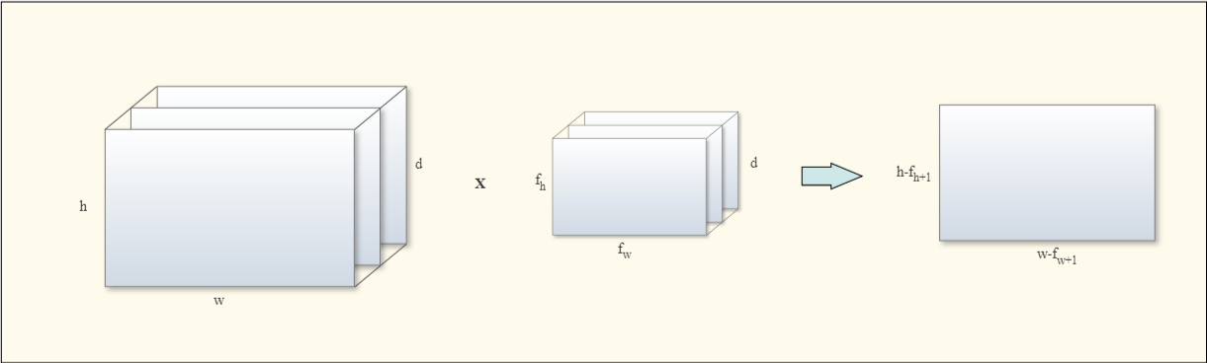

w

w-fw+1

h-fh+1

d

fw

fn

*

d

h

Figure 5.4 Dimension of output image [15]

Consider a 5x5 image matrix whose image pixel values are 0 and 1, and a 3x3 filter matrix as shown in the figure below:

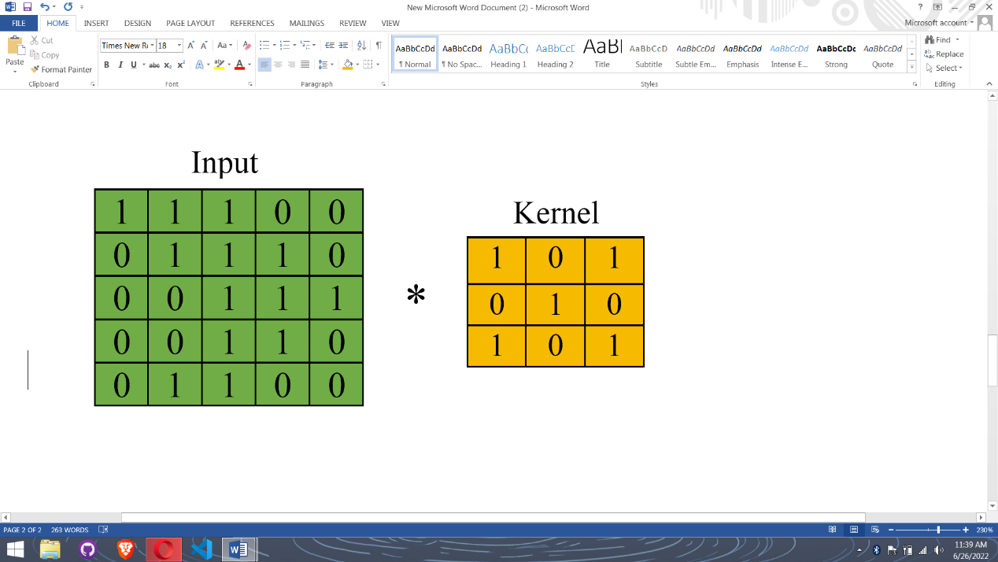

Figure 5.5 5x5 image matrix and 3x3 filter matrix [15]

Then the convolution of 5x5 image matrix multiplied with 3x3 filter matrix which is called a feature map as output shown below:

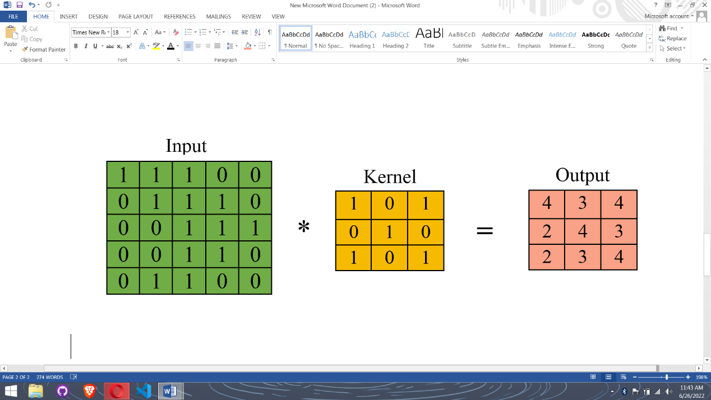

Figure 5.6 Feature map after convolution [15]

The resulting layer is then normalized by modifying and scaling the activations. To speed up learning, we normalize features that range from 0 to 1 and some that range from 1 to 1000. The amount by which the hidden unit values change about, also known as covariance shift, is reduced via batch normalization (Y. Z. S. N. Xueqing Deng, 2018).

Because it has a minor regularization impact, it also reduces overfitting. It adds some noise to each concealed layer's activations, similar to dropout. As a result, we will require less dropout if we utilize batch normalization, which is a positive thing because we will not lose a lot of data. However, batch normalization should not be relied upon just for regularization; it is always preferable to combine it with dropout.

The model employs a variety of nonlinear functions to introduce nonlinearity in the outputs. Our models used the following nonlinear activation functions: **Sigmoid activation function**: It is an activation function of form,

**f(x)= 1/(1+exp(x))**………………………………………………………………...(5.11)which ranges between 0 and 1.

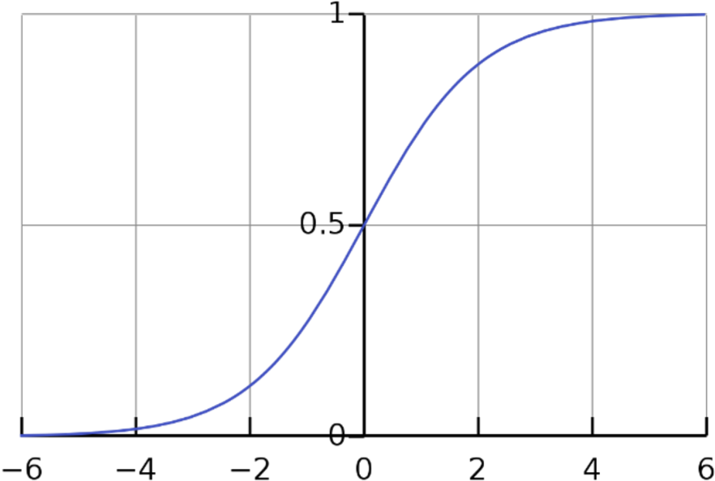

Figure 5.7 Sigmoid function [11]

1. **Hyperbolic Tangent function –tanh**: Its mathematical formula is,

**f(x)=(1-exp(-2x)) / (1-exp(-2x))**………………………………………………….(5. 12)

Now its output is zero centered because its range is between -1 to +1 i.e. (-1 < output < +1).

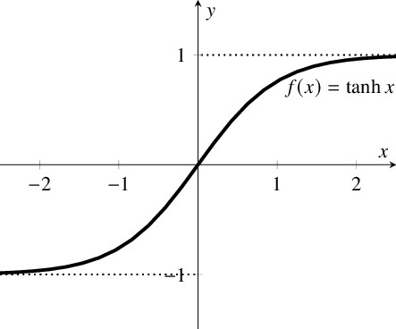

Figure 5.8 Hyperbolic tangent function [11]

1. **ReLU, Rectified Linear Units**: It's merely a feature. If x is less than zero, R(x) equals zero, and if x is more than zero, R(x) equals x. As a result, we can see from the mathematical structure of this function that it is highly simple and efficient, and practically all deep learning models presently employ ReLu. However, it should only be employed within the hidden layers of a Neural Network Model.

Another issue we see in ReLU is the Dying ReLU problem, in which some ReLU neurons essentially die for all inputs and remain inactive no matter what input is supplied; no gradient flows and if a large number of dead neurons exist in a neural network, its performance is harmed; this can be corrected by using what is known as Leaky ReLU, in which the slope is changed to the left of x=0 in the above figure, causing a leak and extending the range of ReLU.

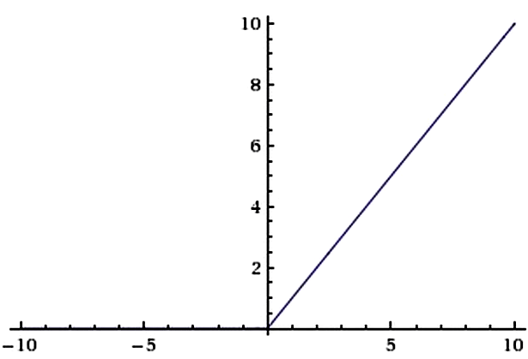

Figure 5.9 ReLU [14]

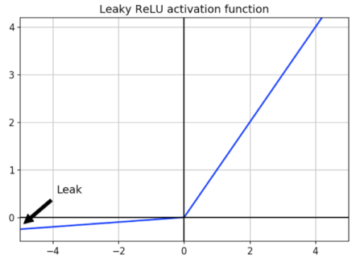

Figure 5.10 Leaky ReLU [14]

**5.2.7 Hyper-parameters**

As suggested by the paper [3], the values of the hyper-parameters to train the model:

Batch size = 1

Epochs = 100

Input and output image size = 256 X 256

Learning rate = 0.0002

Momentum [β1, β2] = [0.5, 0.999]

Max Pool = 2 X 2 (Strides = 2)

# RESULT AND ANALYSIS

**6.1 Result**

We needed to test and analyze the system after the project was completed in order to see what the system's output was. Given the satellite image as input, the intended outcome is obviously a layered map, as our research is built on conditional GAN to produce layers of maps from satellite photos. Our technology will build a detailed map representation of a satellite image that the user provides as input. The output has provided us with a very satisfactory result. If any image other than a satellite or drone image is used as input, the result is garbage, i.e. the standard map image is not obtained.

**6.2 Generator and Discriminator Loss**

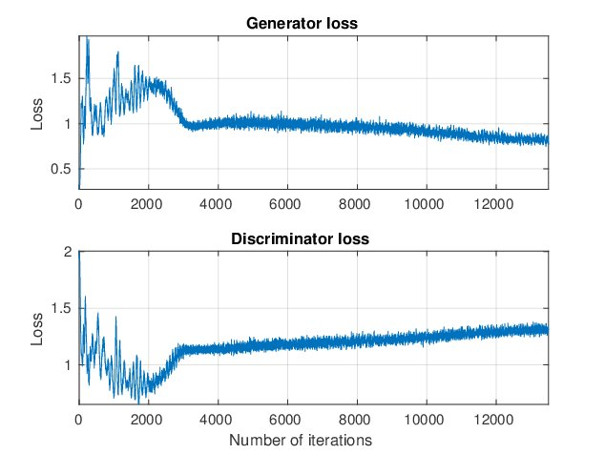

Figure 6.1 Generator and discriminator Loss

A graphical illustration of the generator and discriminator loss is shown in the image abov­­e. The generator tries to persuade the discriminator that the created image is from the original distribution, while the discriminator tries to verify it. The loss value dramatically lowers and begins to stabilize when the generator learns more and more images, as seen in the generator loss graph on the left. This suggests that the generator has been able to consistently produce better and better images while also fooling the discriminator.

The discriminator was able to correctly categorize real and fake images in the beginning, as shown on the discriminator loss graph on the right, but as the generator improves, the discriminator's capacity to do so decreases. The overall discriminator loss is the sum of the "genuine" and "false" image losses. As a result, the discriminator's loss function aims to minimize the error in predicting actual images from the dataset and bogus images from the generator. The generator's loss function minimizes the discriminator's correct prediction on false images conditioned on the provided one-hot labels.

### 6.3 Testing

### 6.3.1 Testing for output result of satellite images

Satellite images was inserted and the output was observed in the system. The result was observed as following.

Table 6.1 Testing for the output for satellite or drone images

|  |  |
| --- | --- |
| **Objective** | To obtain standard generated map. |
| **Action** | Aerial image was inserted and convert button was clicked. |
| **Expected results** | Standard maps with correct representation should be displayed. |
| **Actual results** | Standard maps with correct representation of the inserted maps is displayed. |
| **Conclusion** | Successful |

### Testing for output result of images other than satellite images

Random images other than satellite or drone images, garbage images was inserted in the system and the following result was observed.

Table 6.2 Testing for the output of garbage images

|  |  |
| --- | --- |
| **Objective** | To check result after insertion of garbage images. |
| **Action** | Garbage image was inserted and convert button was clicked. |
| **Expected results** | Garbage image, image other than standard maps should be displayed. |
| **Actual results** | Garbage image, image other than standard maps is displayed. |
| **Conclusion** | Successful |

# ­­­­CONCLUSION

The project's main goal was to create a system that can build a standard map from a satellite or drone image as an input. In this research, a conditional GAN model was used. In picture to image translation, the Generative Adversarial Network (GAN) has been a prominent model. Datasets were manually collected, and training was done using Google's Collaborator notebook.

Our project's goal of creating maps from aerial photos of cities was accomplished effectively. Traditional cartography takes a long time and costs a lot of money, so the overall efficiency of the system is questionable. Our system has appropriately solved this challenge, and by prioritizing time and money, our system can generate suitable maps of corresponding aerial pictures in a matter of seconds.

Finally, the project's core functionality and goal, which was to build standard layer maps from satellite pictures using conditional GAN, were met effectively for this project. Using conditional GAN, we presented a viable method for generating maps. The displayed findings are for 100 epochs. The project may also have some limits and future enhancements, some of which are stated below.

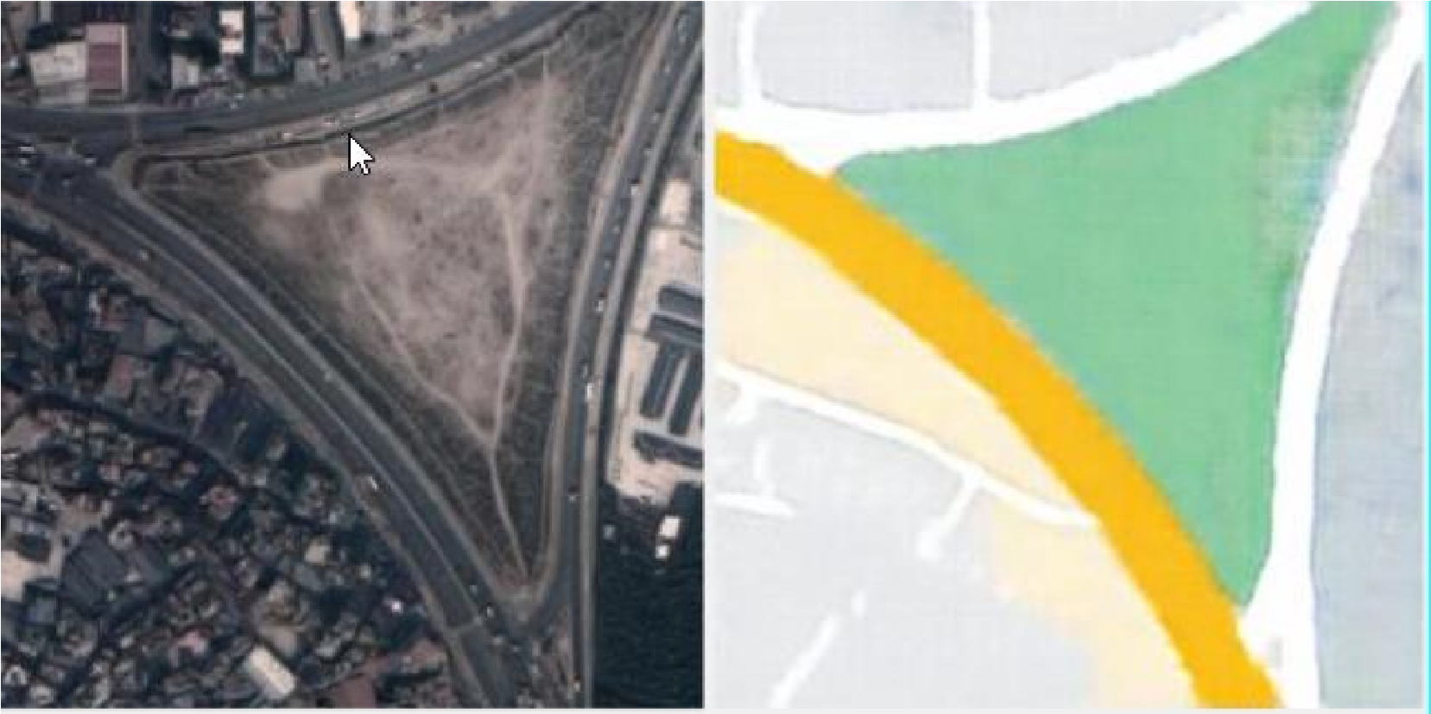

*Figure 7.1: Maps including roads, highway and open land generated*

# RECOMMENDATIONS

The dataset used was not sufficient enough to produce accurate model. This can be improved by using more standard datasets with larger number of images. To give more significance to the system we can add altitude, distance, weather and other parameters as a condition in a conditional generative adversarial network along with a map. Furthermore we can implement the 3D version of maps.

# REFERENCES

1. W. Lira, “*GANHopper: Multi-Hop GAN for Unsupervised Image-to-Image Translation,*” 2020.
2. I. Goodfellow, “*arxiv,*” 10 June 2014. [Online]. Available: https://arxiv.org/abs/1406.2661. [Accessed 2021].
3. J.-Y. Z. Phillip Isola, “*arxiv,*” 21 November 2016. [Online]. Available: https://arxiv.org/abs/1611.07004. [Accessed 2021].
4. “*arxiv,*” 21 January 2021. [Online]. Available: https://arxiv.org/abs/2101.08629. [Accessed 2021].
5. M. Mirza, “*Conditional Generative Adversarial Nets,*” Montreal, 2014.
6. M. D. M. M. A. R. B. C. Hajar Emami, “*SPA-GAN: Spatial Attention GAN for*”, 2020.
7. B. Z. Chunxue Xu, “*Satellite Image Spoofing: Creating Remote*”, Oregon, 2018.
8. Y. Z. S. N. Xueqing Deng, “*What Is It Like Down There? Generating Dense Ground-Level Views and Image Features From Overhead Imagery Using Conditional Generative Adversarial Networks,”* California, 2018.
9. C. Finch, “*Techwalla,*” 25 05 2020. [Online]. Available: https://www.techwalla.com/articles/how-often-does-google-maps-updatesatellite-images. [Accessed 19 02 2022].
10. D. Costea and A. Marcu, “*Creating Roadmaps in Aerial Images with GAN,*” 2017.
11. Gibbs, M.N. (Nov 2000). *"Variational Gaussian process classifiers".* IEEE Transactions on Neural Networks.
12. T. Carras and S. Laine, “*A Style-Based Generator Architecture for Generative Adversarial Networks,*” 2019.
13. A. Casanova, “*Instance-Conditioned GAN,*” 2021.
14. Brownlee, J., 2022. A Gentle Introduction to Generative Adversarial Networks (GANs). [online] Machine Learning Mastery. Available at: <https://machinelearningmastery.com/what-are-generative-adversarial-networks-gans/> [Accessed 23 May 2022].
15. Z. Wang, “*Research Gate,*” August 2019. [Online]. Available: researchgate.net.

[Accessed 2021].

1. G. Ladhar, “*Pianalytix,*” [Online]. Available: https://pianalytix.com/cnnconvolutional-neural-network/ [Accessed October 2021].

## APPENDICES

## 10.1 Some snapshots of the project



Figure 10.1 System User Interface

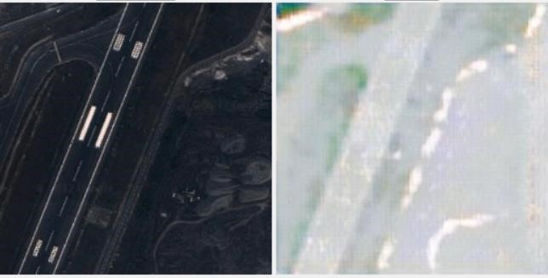

Figure 10.2 Maps including roads

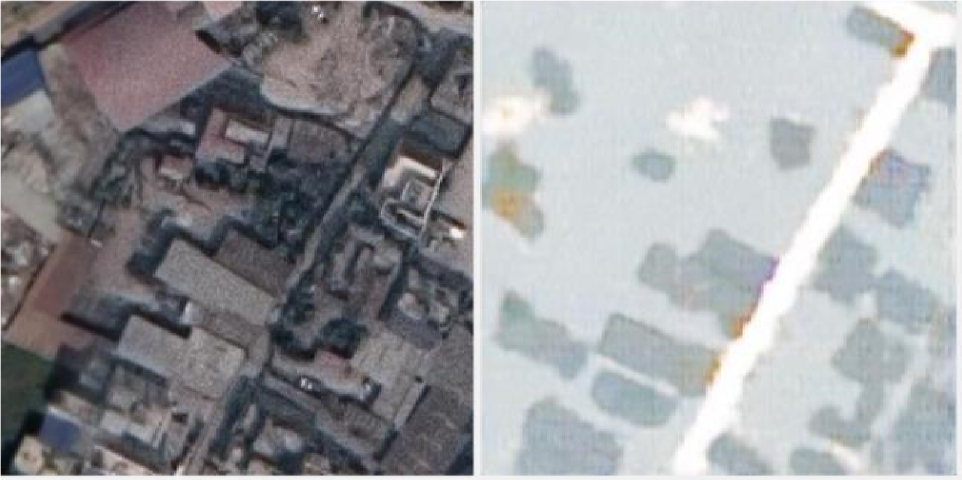

Figure 10.3 Maps containing roads and buildings

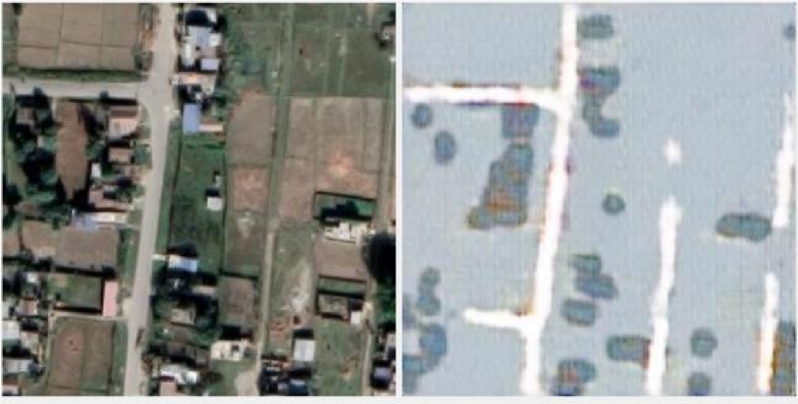

Figure 10.4 Maps containing roads and open lands

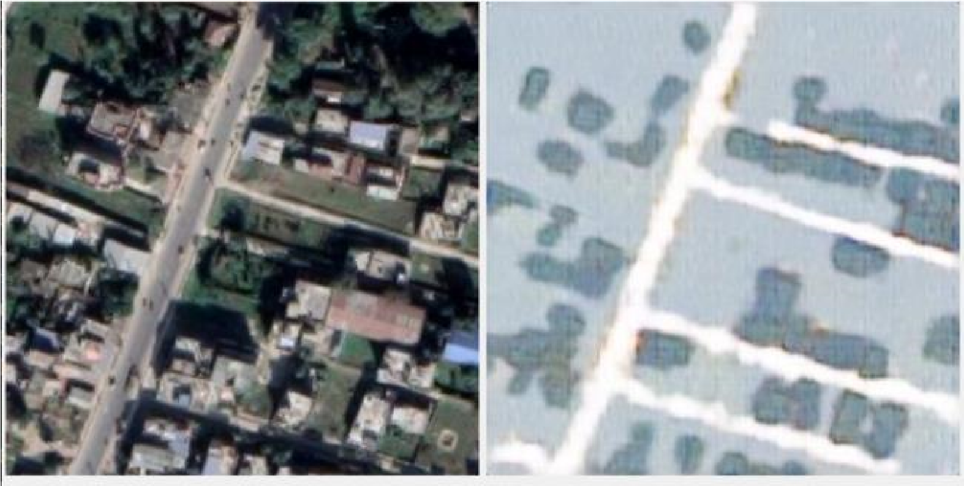

Figure 10.5 Maps containing roads, buildings and open lands

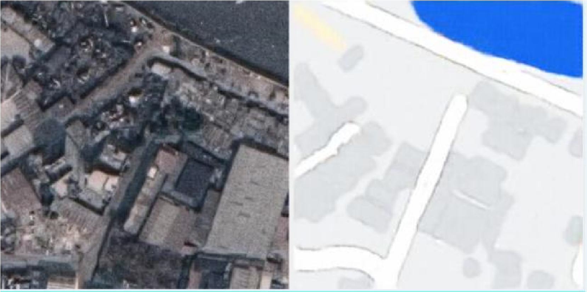

Figure10.6 Maps containing roads, buildings and lake

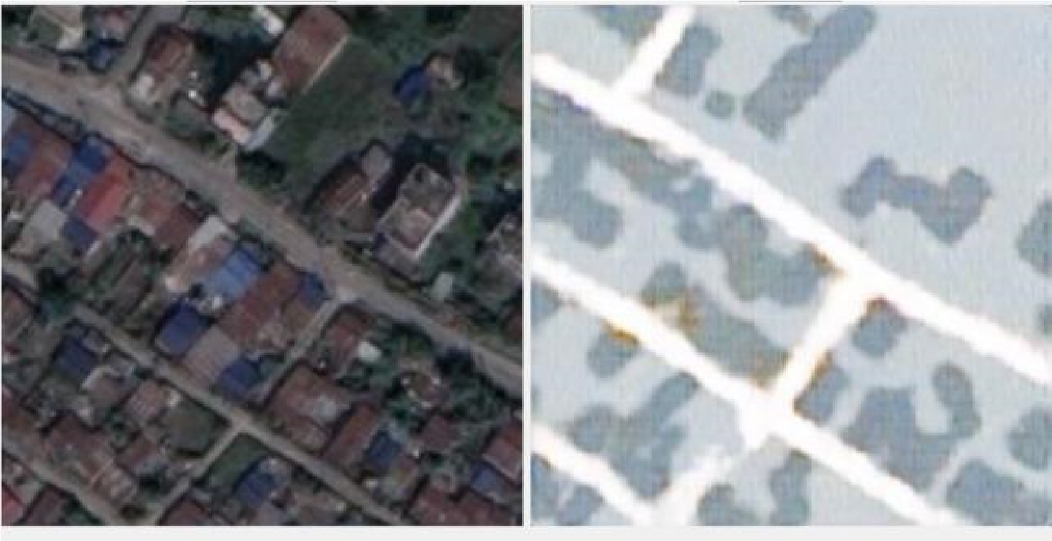

Figure 10.7 Maps containing roads and buildings

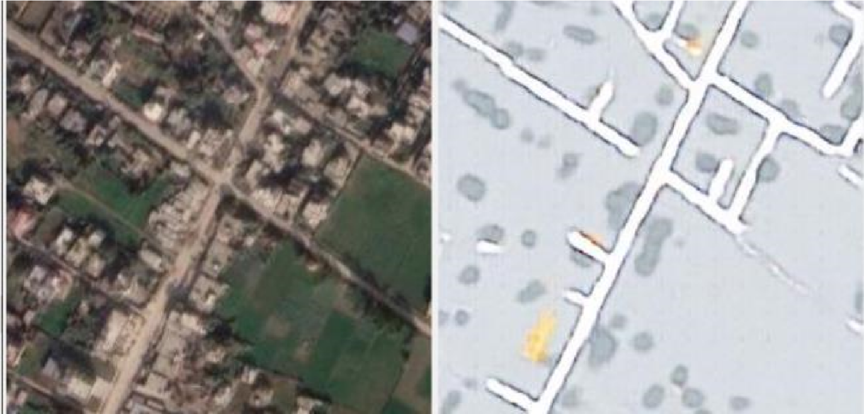

Figure 10.8 Maps including roads, buildings and open lands

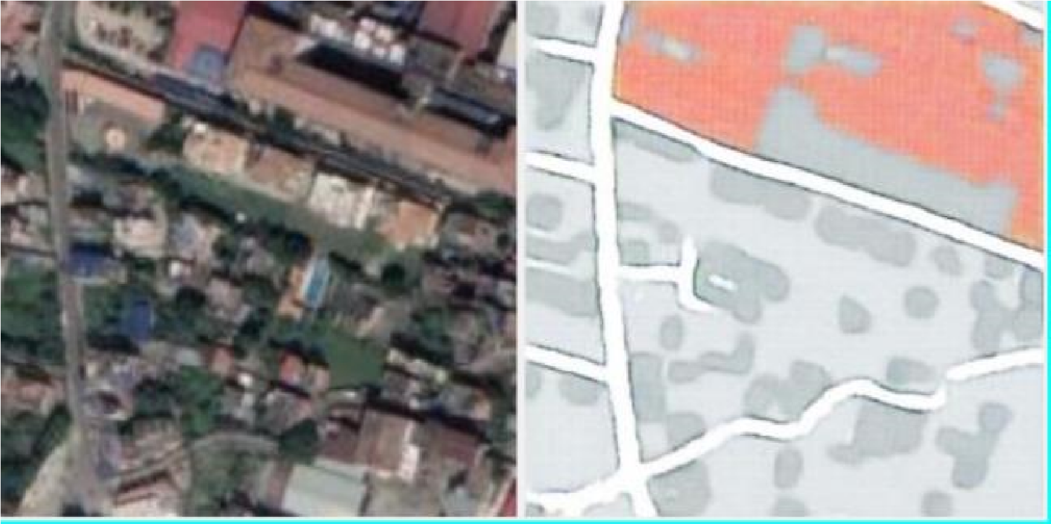

Figure 10.9 Maps including roads and buildings

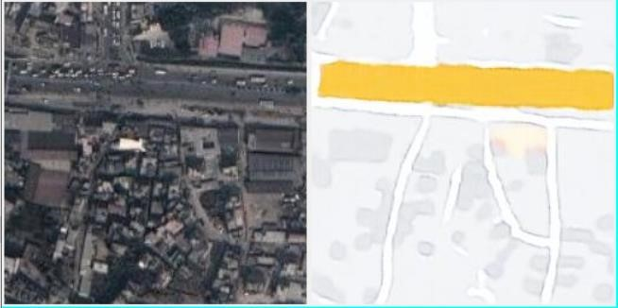

Figure 10.10 Maps including roads and highways